

CS214: Design & Analysis of Algorithms
STEMP

Special Final Examination Semester II, 2023

F2F/Blended Mode

Duration of Exam: 3 hours + 10 minutes
Reading Time: 10 minutes Writing Time: 3 hours Total Marks: 40
The exam covers the following learning outcomes:
CLO – 1: Evaluate the efficiency of algorithms (32.5%)
CLO – 2: Assess the suitability of different algorithms/data structures for solving a given problem (17.5%)
CLO – 3: Solve computationally difficult real world problems using appropriate algorithmic techniques (50%)

Instructions:
- Write your answers in the space provided in this Question Paper.
- Answer all questions. There are 9 questions and all questions are compulsory.
- This exam is worth 40% of your overall mark. The minimum mark to pass the final exam is 16/40.
- The total number of pages including this cover sheet is 14.
- This is a closed book exam. No printed materials and electronic devices are allowed.
ID: Name:
SeatNo: Campus:

This page is intentionally left blank

[8 mins]

When efficiency is the main concern, I generally prefer using ArrayList over LinkedList in most cases. ArrayList provides O(1) random access, making it ideal for algorithms that frequently access elements by index, and its contiguous memory structure offers better cache locality and lower memory overhead. Additionally, appending to the end of an ArrayList is efficient with amortized O(1) time. On the other hand, LinkedList is more suitable when frequent insertions or deletions occur in the middle of the list, as these operations are O(1). However, ArrayList is usually more efficient for typical use cases.

a) Find the worst-case time complexity:
final int P = 200;
final int Q = 100;//where Q is always less than P

for (int i = 0; i < P; i++) {
for (int j = 0; j < Math.min(i,Q); j++) { System.out.println(j);
}
}

O(P×Q)

int a = 0;
for (i = 0; i < N; i++) {
for (j = N-5; j < N; j++) { a = a + i + j;
}
}
10 mins
O(N)

[5 mins]

To empirically determine the Big O time complexity of an algorithm, you can test it with various input sizes and measure its runtime. Start by selecting a range of input sizes (e.g., 100, 200, 400) and run the algorithm multiple times for each size to calculate the average runtime. Use a high-precision timer to record execution time, then plot the input size against the runtime. Analyze how the runtime grows as the input size increases, comparing it to known complexity patterns like O(N), O(N^2), or O(log N). This helps you identify the algorithm's time complexity based on observed trends.

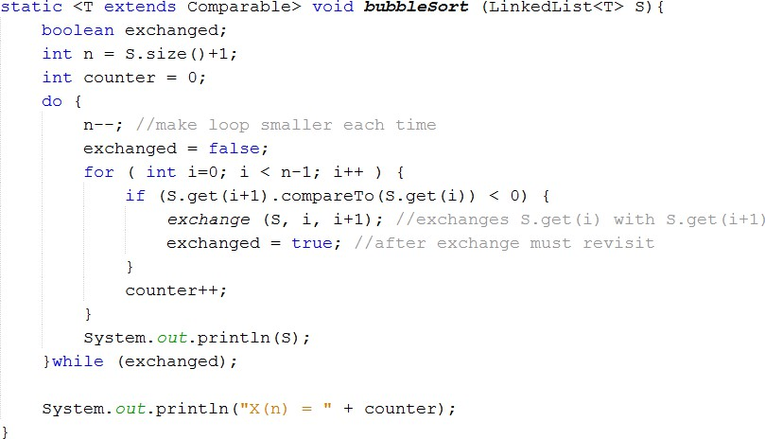

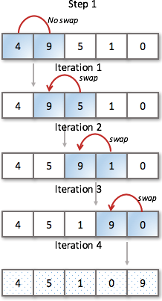
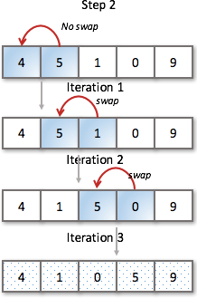
…

(answer both questions 4(a) and 4(b) here)
[6 mins] + [6 mins]

This is a poorly written code. Best case for the given algorithm would be any order OR it will have everycase T(n): #1M
B(n) = n + n + … + n = n*n = n^2. #1M (with working otherwise 0)
Worst case is same as above: #1M
W(n) = n + n + … + n = n*n = n^2. #1M (with working otherwise 0)

class Algorithms{
public static void GA(){…} //… means hidden code
public static void RA(){…} //… means hidden code
[15 mins]

class GATask implements Runnable {
@Override
public void run() {
// Run the GA algorithm
Algorithms.GA();
}
}

class RATask implements Runnable {
@Override
public void run() {
// Run the RA algorithm
Algorithms.RA();
}
}
public class AlgorithmRunner {
public static void main(String[] args) {
// Create the GA and RA tasks
Runnable gaTask = new GATask();
Runnable raTask = new RATask();

// Create threads for both tasks
Thread gaThread = new Thread(gaTask);
Thread raThread = new Thread(raTask);

// Start both threads
gaThread.start();
raThread.start();

// Optional: Wait for both threads to finish (if necessary)
try {
gaThread.join();
raThread.join();
} catch (InterruptedException e) {
e.printStackTrace();
}
}
}

Knapsack Problem:
For the 0-1 Knapsack problem, the best algorithmic design paradigm to use is Dynamic Programming (DP). DP is well-suited for this problem because it breaks the problem down into smaller subproblems and uses the results of these subproblems to build up the final solution. Specifically, the problem can be solved by constructing a 2D table where one dimension represents the items and the other represents weight capacity. This ensures that we explore all possible item-weight combinations, providing an optimal solution. While the time complexity is O(nW)O(nW)O(nW) (where nnn is the number of items and WWW is the capacity), it's still practical for many real-world applications despite being NP-complete.
N-Queens Problem:
For the N-Queens problem, Backtracking is an ideal paradigm. The problem involves placing queens on the board one by one and checking constraints (no queens attacking each other). Backtracking systematically explores all possible placements of queens but prunes solutions when constraints are violated, making it more efficient than brute force. While it is exponential in time complexity, the pruning in backtracking makes it feasible for moderately large values of nnn. Other alternatives include genetic algorithms for approximate solutions when the problem size becomes too large for backtracking.

Character | Frequency | Code
B | 2 | 01111
F | 1 | 01110
H | 3 | 0110
I | 10 | 00
L | ? | 010
M | 15 | 10
S | 15 | 11

[15 mins]
item 1 (3kg, $5) item 2 (1kg, $2) item 3 (4kg, $7) item 4 (2kg, $3) item 5 (5kg, $8)
The knapsack has a capacity of 10 kg.

Do the following by showing your complete working:
[10 mins]

[15 mins]

[15 mins]

